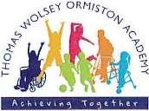
New Allergies

Please use this form to let the school know of any new allergies your child has developed as soon as possible.

New Allergy

Name of child
Date of birth
Known allergy to
Reaction
Action to be taken

Signed: Print Name:

Relationship to child: Date:

