
TWOA
E-Safety Bulletin for Families
Sept 25
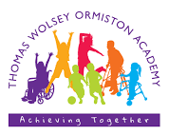

Vecteezy.com

Welcome
Dear Families,
Welcome to our first e-safety bulletin. Keeping safe in the online world is a challenge to us all. The online landscape is constantly changing and it can be difficult or confusing to navigate.

Many of the children at TWOA need our help to access the online world and this provides them with an extra layer of protection but some don’t and we know with our children’s additional needs, this can make them especially vulnerable. We know that many of our children, once supported to access a favourite site have the skills to navigate their way around it and even off it, whether by choice or accident and if appropriate parental controls are not in place, they can end up being exposed to harmful content.

Luckily there is lots of support available to help us all remain safe. You will find links to these on our website. We have also included them here as a reminder.

You may have heard about the 4 Cs. Risks in the online world can be grouped into one of these. They are Content, Contact, Conduct and Commerce.
Content – Whilst there is a lot of content online that is beneficial, there is a lot that is misleading, inappropriate or even harmful. We need to learn to critically evaluate the content we view. This is not always easy.

Contact – Whilst we all know that there are people out there who may be posing as someone they are not, contact is also about protecting our children and young people from contact by people they may know where the relationship is unhealthy.

Conduct – This area emphasises the importance of respectful and responsible online interactions, including content sharing and community participation. The anonymity of the internet can pose a risk as people think they can get away with negative behaviours.

Commerce – There are many financial risks in the online world and it is easy to get into deep water through advertising, online shopping, in-app purchases and the risks of online gambling and scams.

Online Links for Families

Parentzone is designed with families in mind. It is realistic about modern lifestyles and the realities of raising children in a digital age. It is free. You will need to register.
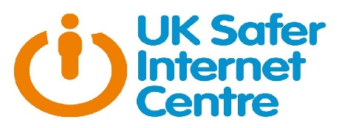
The UK Safer Internet Centre provides resources and advice for families, professionals and young people themselves. The site is well-organised and easy to navigate.

Childnet is a charity that provides lots of up-to-date support and advice for professionals, families and young people themselves.

Mobile Phones, Our School Policy & Building Healthy Habits
Navigating the technological age means not only keeping our children and young people safe from online risks, it is also about encouraging healthy habits and making sure they have opportunities to have time away from screens.
You may be aware that there is a lot in the media at the moment about phone-free schools. Many schools, are moving towards a ban on phones. There is evidence to support this move both for pupil achievement and well-being.
Our situation at TWOA is a little different. As a result our policy around this is a little different. Please do have a look on our policies page on the website to find out more about our policy around mobile phones and what you must do and must be aware of if you think bringing a phone into school may be beneficial for your child. Thomas Wolsey Ormiston Academy - Policies & Privacy Notices

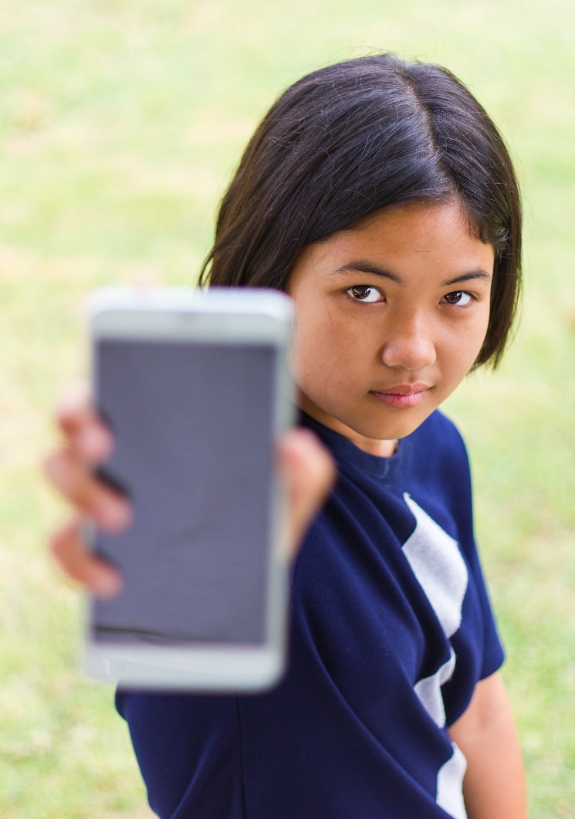

Radicalisation
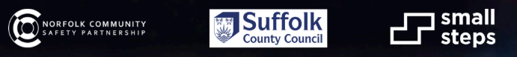
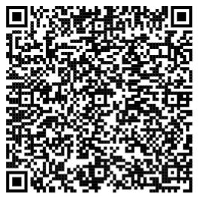
Also in the news, the risks posed by extremist organisations through online grooming and exposure to potentially harmful content.
The QR code links you to a free webinar run by the Norfolk and Suffolk Community Safety team designed for an adult, whether professional or parent/carer who would like to find out more about how they can protect the children and young people in their care from the harms of radicalisation.
There are 3 sessions to choose from during October and one in November.

