
TWOA
E-Safety Bulletin for Families
Oct 25
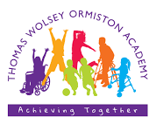

Vecteezy.com

Make time to talk
Dear Families,
Welcome to our October e-safety bulletin. The online world brings many benefits and it is here to stay.
Our job as parents/carers and professionals who work with children is to stay informed of the online spaces that our children inhabit and make sure that these spaces are safe places to be.
Findings from a report carried out this year by the Children’s Commissioner, captured the thoughts and feelings of children and young people around staying safe in the online world. The report found that children expect to be kept safe, just like in real-life communities. They want more support and protection online and they want parents to check-in regularly, even if they seem reluctant to talk.
“They told me that they wanted adults in their lives to ask them about the content they were seeing.” (Children’s Commissioner)
Many children reported being exposed to harmful content online and they worry about this. Algorithms promote harmful material, even when children don’t seek it out. The report found that children say:
“This type of content stays online too long and is available too frequently, even when reported.”
Coming across harmful content online is not unusual. Accessing content through apps rather than directly from the browser, can mean that certain parental controls get bypassed.
There are lots of ways to reduce the possibility of exposing children to harmful content accidentally. At home you can set parental controls on your child’s device and make sure that they are closely monitored if on a shared device. In school we have a robust filtering system in place. All children have their own accounts set to the hghest security setting.
Despite this, no system is 100% secure and the older and more independent your child gets, the higher the likelihood is that they will be exposed to harmful content of some form or another.
Report it!
The Online Safety Act came into force in 2023. It is designed to make the internet safer—especially for children — by placing legal duties on tech platforms to manage harmful and illegal content.
The Act specifies the need for clear reporting mechanisms to be in place for harmful content. Platform safety settings also need to be in place and parents/carers are encouraged to use them.
Harmful content, (which may include anything from personal comments, images or extremist views) can be reported using in-built tools on the platform itself. If you are unsure how to do this, a quick and easy way is to use AI. Carrying out a search in Chat GTP for example will tell you quickly and easily.
There are also other dedicated online spaces where you can report different types of content depending on what it is.
Dedicated reporting tools

This tool is run by the UK’s Safer Internet Centre. You can report harmful content such as bullying or harassment or violent or disturbing material etc.
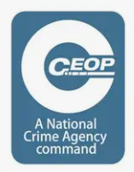
Surprising numbers of children and young people communicate with people they don’t know online – particularly through gaming platforms or social media. People are always who they say they are. Ceop is a reporting tool where young people can report if they feel uncomfortable with the way someone has been communicating with them online, especially of a sexual nature?
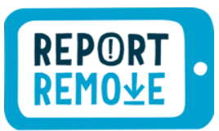
This tool is run by the Internet Watch Foundation. It supports children and young people who may be aware that there is an inappropriate image of themselves online. This is known as CSE (child sexual abuse) due to the rules around non-consensual images of children.


ACT or Action Counters Terrorism is where you would report something that may be linked to terrorism.

The UK Gov also has a dedicated space where you can report online material promoting terrorism or extremism.

