
TWOA
E-Safety Bulletin for Families
Jan 26
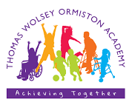

Vecteezy.com
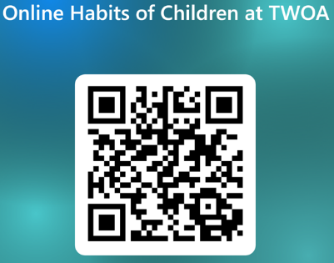

What I wish my parents or carers knew – part 2
Dear Families,
Welcome to our January e-safety bulletin. This edition focuses on the guide published by the Children’s Commissioner for England to help parents and carers manage their children’s digital lives.
The guide aims to explain common online challenges, help families start and sustain open conversations, and provide support with setting boundaries. The guide includes a checklist of actions and an additional activity pack for children.
Please read this e-bulletin alongside the December bulletin and please support us with the work we are doing in school by completing our online survey about the online habits and experiences of the children and young people at our school.
You can do this by clicking on this link https://forms.office.com/e/yq8U8GEZgM or scanning the QR code to the right.
This survey is short and you can answer it anonymously. Please do try to find a few minutes to complete it and do get in touch with us if you would like to talk to us about any of concerns you have about your child’s online experience. We don’t claim to have all the answers but we know that by working together we will help keep children and young people safer.

Read this short blog post…
This blog was posted on 18th Dec 2025 by the Children’s Commissioner for England.
Extract from the post: “The message I want you to walk away with is to talk early and to talk often. Meet your child with patience, compassion for them navigating this new and rapidly developing world – the same compassion we deserve for ourselves – and with kindness. Trust your instincts – and take the steps to educate yourself.”
You can find the blog post by clicking on the link below or scanning the QR code
‘What I wish my parents or carers knew

You can find the guide by clicking on the link below or scanning the QR code
A guide for parents and carers
