
TWOA
E-Safety Bulletin for Families
June 26


Vecteezy.com

Screen time
Dear Families,
Welcome to the June e-safety bulletin. In this edition, we will be taking a closer look at screentime, how to strike the balance between offline and online fun and how we can support our children to self-regulate.
Not all screen time is equal!
Parentzone (one of many very helpful websites out there to support parents keep their children safe in the online world) reminds us that ‘It’s important to remember that not all screen time is equal.’ Their advice is to ‘try to see your child’s time spent online in terms of screen use, rather than screen time: consider what they are doing, rather than just how long they spend doing it.’
‘The internet can offer important opportunities for social interaction, creativity, education and most importantly, play. Time spent playing games, watching videos or chatting with friends is definitely not a waste of time.’
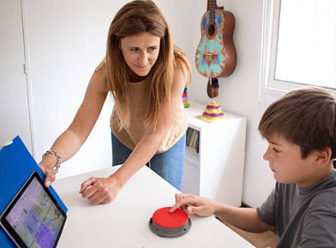

It’s all about balance
Striking the balance between time online and offline is not always easy but the benefits of establishing good habits and routines early on will mean that your child will be more likely to regulate their own behaviours as they grow.
Encouraging interests in offline activities supports with physical, emotional and social development. Too much time online can become habit-forming and can impact negatively on emotional well-being as well as physical health.

Keep Talking!
The online world is here to stay. It is the world our children have grown up in and they know no other world. However, just like the offline world, they need our guidance and help to navigate it safely. We know, from national online surveys, they want our help, even if, in the moment, it doesn’t always feel that way!
As parents and teachers, we can put measures in place to support our children build good habits and routines, such as limiting screen time or setting filters in the parental controls or introducing a ‘no phone’ policy during school hours. (As of April 2026, mobile phones became legally banned in schools across England).


However, as with all e-safety, our ultimate goal is for children to learn to self-regulate, know when to come away from the screen and do something else instead.
As children get older, explaining, however simply the reasons why responsible screen use is better for them, is always better than a draconian ban which is likely to be counter-productive.
Set boundaries and model good habits and routines
Setting clear, consistent boundaries helps children know what to expect. For those children that need things explained very simply, this can be done through the use of visual time-tables or only allowing screens in certain places at certain times, e.g. not in bathrooms or at the dinner table or not an hour before bed.
Discuss different rules for weekends and holidays but always be clear and consistent over what the rules are.
Above all else, practice what you preach and be a digital role model. Modelling a healthy relationship with tech will allow your child to develop one too.

