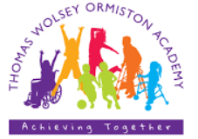

Thomas Wolsey Ormiston Academy

Special Educational Needs (SEN) Information Report
Last reviewed on: | Sept 26
Next review due: | Sept 27


Introduction
The aim of this information report is to explain how we implement our SEND policy.

We hope parents of current and prospective children find the following information helpful and we encourage you to contact the academy for more information.

If you want to know more about our arrangements for SEND, please read our SEND policy. You can find it on our website, on our policies page Thomas Wolsey Ormiston Academy - Policies & Privacy Notices

At Ormiston Academies Trust, we are committed to delivering an equitable, high-quality education that recognises and nurtures the unique strengths and potential of every child.

At Thomas Wolsey Ormiston Academy, we are a nurturing, ambitious and inclusive special school where every pupil is valued as an individual, empowered to overcome barriers, and supported to achieve their fullest potential

If you would like to have this report read aloud as an audio, you can use a free reader at: https://www.naturalreaders.com/. If you have any difficulties accessing this report, please contact the academy and we will support you.

If there are any terms we’ve used in this report that you’re unsure of, you can look them up in the glossary at the end of the report.


Name and contact details of key staff

SENCO  Helen Dickenson  Co-Principal  DSL  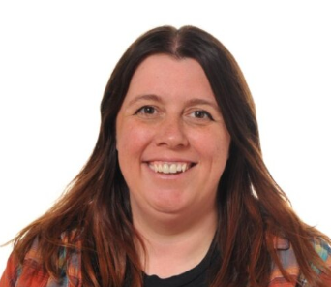 | Title  Emily Webster  Co-Principal  DDSL  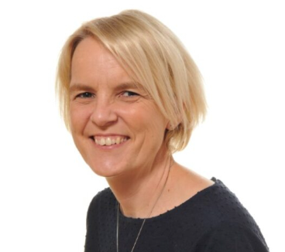 | Title  Amanda Jebb  Lower School Lead  Behaviour Lead, DDSL  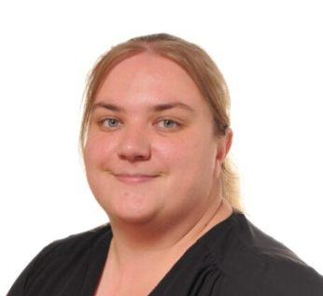 | Title  Laura Goodfellow  Middle School Lead  Enrichment Lead  DDSL  
Miglena Gencheva  Upper School Lead  Careers Lead  DDSL  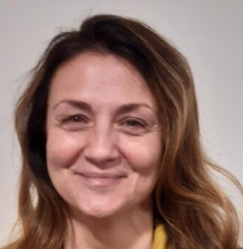 | Wasim Butt  Education Director  Safeguarding Lead at OAT   | Lynne Goodwyn  Chair of Governors  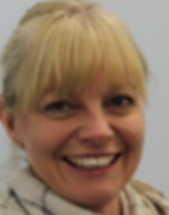 | Suzie Hawkins  Lead SSA  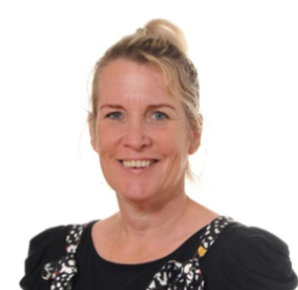
Danielle Hayward  HCA   | Kelly Root  HCA   | Jodie Cook  Lead Swimming Instructor  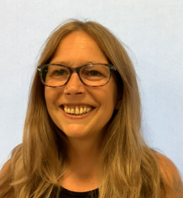 | Rachel Shave  Play Leader  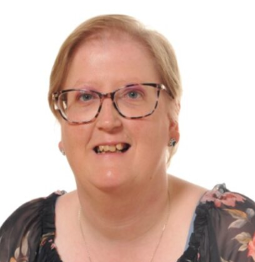


The kinds of SEND we provide for in our academy
At our academy, we provide support for children with a range of needs, including the following:

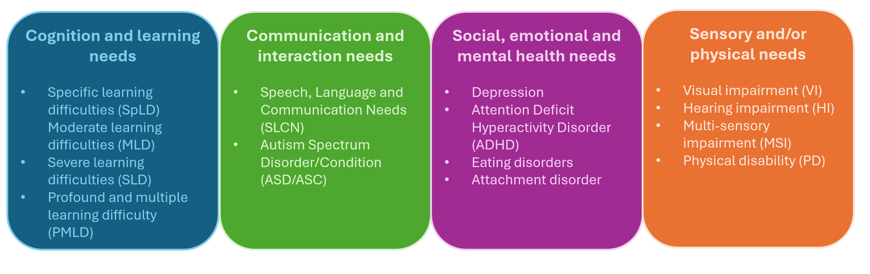

We are a specialist provision for children with complex physical, medical and / or sensory needs with associated learning difficulties.
We cater for pupils from 3-16 years.


Here is our SEND data, correct at time of publishing
 | Number | % of cohort
No SEND | 105 | 100
SEN Support (K) | 2 | 2%
EHCP (E) | 103 | 99%

 | EHCP  (number / %) | SEN Support (K)  (number / %) | Total  (number / %)
Cognition and learning | 103 | 2 | 100
Communication and interaction | 94 | 2 | 91
Social, emotional and mental health | 11 | 0 | 11
Sensory and/or physical | 94 | 2 | 91


How we identify SEN and assess needs
The Local Education Authority consult the Academy on children with identified SEND who they believe match our provision. These children will have been referred to the Local Authority’s Specialist Admissions Team by the Inclusion Service or other professionals working in early childhood settings. These children may or may not have an EHCP. (Education, Health and Care Plan). Based on paperwork and a visit to the setting, we will assess their suitability for a place at the Academy Assessment Nursery or, if they have an EHCP, are of statutory school age and a place is available, within the Academy itself. Any children who do not have an EHCP will need to be assessed for one. During this process, they will be assessed by a range of professionals including advisory teachers, educational psychologists, paediatricians, health visitors and GPs to decide what longer-term provision they need and whether the Academy is the best placed to meet them. A Local Authority SEND panel makes the final decision as to whether their needs will be met by TWOA once they reach statutory school age.


How we work with children and their families
We work very closely with our families to ensure the provision we offer is right for each child. All our provision is bespoke to each individual so gathering the views and perspectives of our families is essential to get this right.
The annual review of the EHCP provides is critical in this process as well as formal termly parent contact meetings and regular day-to-day interaction with parents face-to-face on over the phone. EHCP outcomes, short-term targets, bespoke provision is all decided collaboratively with parents.

Wherever possible and appropriate, all children and young people from Year 7 and up attend their review and where appropriate, some younger children may do too. Pupil voice is gathered in a format relevant for that pupil. ‘Consulting' emerging learners and our youngest children must be done through observation, reflective practice and close partnership working with families and other professionals. Tools such as the Engagement Model are rooted in these principles and provide a structure for staff to 'listen' to the voice of the pupil and tailor provision according to each pupil’s interests and motivations.
Where possible, we seek feedback on our curriculum offer and special events from our pupils. Sometimes this is formalised and specifically sought through surveys and evaluation forms and sometimes, it is gathered through observation. Pupils are also encouraged to evaluate educational visits and enrichment experiences and they are encouraged to be involved in the choice and organisation of key events in the school calendar such as fundraising days, sports day, educational visits and activity days.
We pride ourselves in building strong relationships with our families and our pupils. Outside of more formal opportunities to build these relationships, we ensure that there are plenty of opportunities across the school year to meet and connect with each other more informally. This may include everything from parent shares and our annual summer fete to educational visits and special activity days.


How we support children in transitions and in preparing for adulthood
Before a child joins our academy, we gather information in the following ways:

Visiting the child in their home or current setting if they are at one’
Inviting the child into school for one or more visits as needed
Inviting families in for ‘Stay and Play’ sessions or taster days if they are joining the school higher up
Meeting with parents and carers, and other professionals who already know the child or young person to discuss their needs and find out more about them

To help children be prepared for a new school year we:
Create a ‘Transition Book’ for each children to look at over the summer with their parents. These are child-friendly and contain information about their new class and environment for when they return in September
The first day back of each school year is our ‘Meet the Team’ day. Children can come into school with as many of their family members as they like to look around and re-familiarise themselves with school. They schedule a meeting with their new teacher and class staff. This day provides a safe and gentle reintroduction back into school after the long summer holiday.
Parents and carers are able to share any updates with school.

If a child is moving on to a new school, we ensure that any information is passed on in a timely manner.
Transition to post 16 provision begins in Year 9 with preparations for adulthood central to the curriculum offer and annual review process. Year 11s participate in a year-long transition programme which provides them with opportunities to spend time at some of the local FE colleges in their Supported Learning Departments.
Experience of work opportunities in Year 11 also help prepare our older pupils for post 16 provision. Sometimes we are able to arrange bespoke careers-based opportunities tailored to the needs and interests of each child. Other times we arrange more generic opportunities to local social enterprises.
Preparations for adulthood start in Early Years and continue all the way through school.
Through these opportunities and our wider curriculum offer at Key Stage 4, we work with the child to help them achieve their ambitions, which can include goals in further education, employment, independent living and participation in society. We provide all of our children with appropriate advice on paths into work or further education.


How the curriculum and learning environment is adapted to meet the needs of all children and how we make sure teaching is effective for all children
We believe that an inclusive education begins with ambitious, accessible curricula and expert teaching. Leaders carefully design the curriculum to be flexible but rigorous, ensuring that all children can access challenging content.

Information on our curriculum can be found here: Thomas Wolsey Ormiston Academy - Our Curriculum

We aim to ensure every child has access to high-quality teaching as we know this has the greatest impact on outcomes, especially for children with additional needs. CPD supports staff to design lessons with children with the highest needs in mind. We use a range of strategies that remove barriers to learning.

The cognitive ability, types of disability and the age range of our learners varies widely. We therefore employ a wide range of specialist methods and approaches which are driven by the needs of each learner.
We work closely with therapists, social services, sensory services and other professionals to provide a holistic, child-centred, multi-professional approach.
The curriculum is child-centred and combines personalised programmes of study with the class programmes of study to ensure each pupil accesses learning in ways and at a level that is appropriate to their needs and ability whilst
Class sizes are small and have a high staff-pupil ratio to provide learners with the extra levels of support that they need.
The curriculum is organised around the key areas of need of the EHCP to ensure provision is weighted appropriately. Curriculum provision is delivered in full consultation with therapists – e.g. PD (Physical Development Programmes) are developed alongside the Physiotherapists, Communication and Literacy programmes alongside the Speech and Language Therapists.
Further specialist methods and approaches are built into the curriculum offer such as TACPAC, Sensology, sensory-story-telling and music therapy.
The school has a number of specialist learning environments including sensory dens in most classes, a sensory studio and a sensory room for our learners requiring a more immersive environment or intensive sensory work.


Arrangements for assessing and reviewing progress towards outcomes
We follow the “graduated approach” to meeting children’s needs. This is a four part cycle of Assess, Plan, Do, Review.

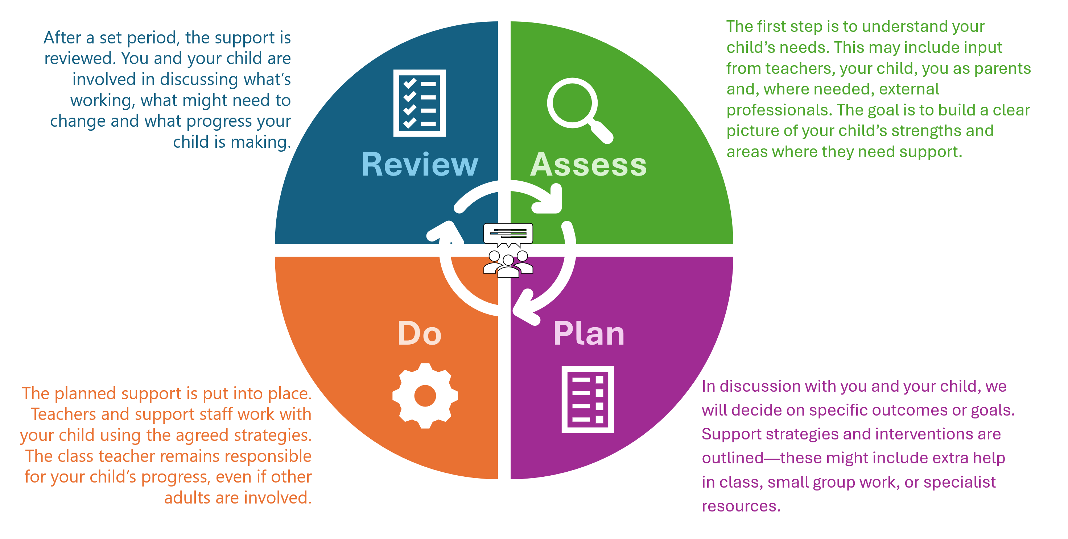
Progress is measured against each pupil’s individual starting points, needs and outcomes rather than solely against age-related expectations. Assessment focuses on the small steps of progress pupils make across academic, communication, social, emotional, physical and independence skills. Evidence is gathered through observations, work samples, assessment data and progress towards Education, Health and Care Plan (EHCP) outcomes, enabling staff to identify achievement, inform future teaching and ensure that every pupil is making meaningful progress appropriate to their age, stage of development and individual needs.
There are a number of mechanisms used at Thomas Wolsey Ormiston Academy to help us identify and measure progress. These include:
Learning Maps & the EHCP
Engagement Model
Route maps
Progress Meetings


How we support emotional and social needs
A strong culture of care is embedded throughout the academy, supported by an effective pastoral framework. We provide a wide range of strategies, support and interventions to help pupils develop their social and emotional wellbeing and achieve positive outcomes.

These include:

- Music therapy – all pupils and targeted support
- Mindfulness & relaxation activities (lunchtime clubs & class-based activities) - all pupils and targeted support
- Emotions & self-esteem work (delivered as part of SEWB curriculum) – all pupils and targeted support
- Sensory alignment specialist approaches – e.g. TACPAC
- Zones of regulation – all pupils where needed and targeted support
- Regulation stations, boxes & other resources, (e.g. sensory spaces (room or dark dens) – all pupils where needed and targeted support
- Sensory stories – targeted support
- DESTY (Developing Exceptional Strengths and Talents in You) - targeted support
- Lego therapy (Brick Club) - targeted support
- Sensory circuits and movement breaks, (may include Rebound Therapy) - all pupils where needed and targeted support
- Trauma-informed practice and understanding through Norfolk Steps Behaviour Management & Early Intervention Programme

As well as this additional support, all children have access to a well-planned Personal, Social, Health and Economic (PSHE) curriculum. More information about this can be found on our academy website in the RSHE Policy on the Policies page. Thomas Wolsey Ormiston Academy - Policies & Privacy Notices


How we make sure that all children can access a wide range of activities
All of our extra-curricular activities and academy visits are available to all of our children. All children are encouraged to go on our trips, including our residential ones. We plan a wide range of exciting opportunities which vary widely from visits to zoo or the forest to in-house events such as school plays or Active Week (our equivalent of Sports Day). No child is ever excluded from taking part in any activities because of their SEN or disability and we will make whatever reasonable adjustments are needed to make sure they can be included.
We believe that all children should have access to meaningful and ambitious experiences, regardless of their individual needs. We actively create opportunities for every pupil to participate in a broad range of enrichment activities. We draw on a range of expertise from our parents, (past and present – many of whom have a lot of experience) therapists and other professionals such as our Moving and Handling instructor, to problem-solve and make things happen. A few of the many opportunities that our children have access to include:
- Sailing, camping and outdoor adventure pursuits
- Performing in theatres and concert venues
- Participation in local, regional and national sporting competitions
- Collaborating with professional artists to create artwork for public display
- Delivering presentations and speaking at major public events


What expertise have our staff got and what training have we had?
We ensure that all of our staff feel confident in meeting the range of needs of our children. Inclusion runs through all of our training so that staff see SEND as a whole academy responsibility.

Any specific training is built into whole academy approaches. As well as this we have staff trained in the following:

All school staff receive a core training offer which ensures the safeguarding and care needs of all children are met. This is an ongoing cycle of training which is refreshed each year through PD days and twilights. It includes safeguarding updates tailored to a specialist school setting, feeding, postural management and positioning for learning, manual handling, administration of medication, management of medical conditions including asthma, epilepsy and anaphylaxis.
Training tailored to individual pupils is offered within class and school time and delivered through the Speech and Language Therapists, Physiotherapists, Occupational Therapists and the Moving and Handling Instructor who are based on site. The CCTN (Community Children’s Nursing Team) offer further medical training and support on a needs basis, e.g. instruction in the use of pump fees, and gastrostomy feed systems.
All staff have Norfolk Steps training which is a Positive Behaviour Management Programme. This is refreshed regularly. Additional training is provided for class teams where further interventions may be required. This is provided in-house by members of the Senior Leadership Team who are trained as trainers.
All members of staff involved with swimming (most class staff) have shallow water training and awareness of the specialist swimming environment, e.g. use of pool hoists.
A wide range of training is delivered by the Speech and Language Therapists and the SCARC (Suffolk Communication Aids Resource Centre) team (also based on site) around the use of AAC (alternative and augmentative communication). Some is part of the core offer, e.g. creating communication cultures and the promotion of total communication in the classroom. The core offer is generally offered during PD days. Bespoke training according to need is delivered during the school day, often with the pupil or the pupil’s device and family members. This includes PECs (Picture Exchange Communication System), eye-gaze or Talkpad programming.
The Sensory and Communication Service offer further bespoke, needs-led training such as VI, (visual impairment) and HI, (hearing impairment) awareness training. A number of staff are first aid trained including paediatric first aid training.
Teachers receive the majority of their ‘learning-based’ training through a weekly teacher’s meeting. This might include use of specialist software such as Clicker or Inclusive Technology, specialist approaches to literacy and numeracy or specialist assessment methods such as the Engagement Model.
Teachers are given opportunities to lead curriculum areas and become the 'in-house' experts in their area by attending specialist training from external providers such as Hirstwood and visiting and linking with other special school leads. Senior Leaders network with other special school settings through membership of organisations such as the 'Special Heads' forum to set up visits for teachers and other staff in school and share best practice.
Teachers are supported to develop their skills through team teaching with expert teachers – our Heads of Department. They are also encouraged to extend their skills by spending time in each others' classes, planning together and sharing ideas and resources. All curriculum planning and resources are stored in shared folders for everyone to access and learn from each other.
Upskilling support staff in SEND teaching and learning techniques and approaches is disseminated via the class teacher through weekly class meetings or through modelling during the school day. All support staff attend a weekly forum with their Head of Department which can provide another training opportunity. All class teams are involved with planning up-coming termly topics where time allows during PD, (professional development) days.
Staff are encouraged and supported to undertake professional qualifications and participate in practitioner-based research. Staff are encouraged to undertake CPD (continuous professional development) of their own developing skills in specialist areas such as Intensive Interaction, Sensory Integration Awareness or Rebound Therapy.


Who else do we work with?
We work in a very multi-professional setting, most of our therapists are based on site and we have many other professionals that visit the school regularly to support us with our work. Some of the professionals we work with include:
- Physiotherapists
- Occupational therapists
- Speech and Language Therapists
- Sensory Impairment Service
- Children’s Community Nursing Team
- Children’s Community Learning Disability Team – Behaviour Support
- CAMHS
- Educational Psychologists
- Specialist Learning Support Service
- Suffolk Communication Aids Resource Centre
- Wheelchair Services
- Suffolk Local Authority – Social Care Services
- Suffolk Local Authority - Schools Transport
- Suffolk Local Authority – SEND Statutory Services
- Suffolk Constabulary

We are co-located with a mainstream Secondary academy. We are currently increasing the range of opportunities for the two schools to engage in a range of shared learning experiences from Duke of Edinburgh to musical productions.

We also have a number of other people who help us provide a rich curriculum experience. A few of these are listed below:
- Whitton Church
- New Wolsey Theatre
- Snape Maltings
- Lord Taverners
- Orchestra of the Age of Enlightenment
- Orwell Panthers
- Woolverstone Project
- EAST
- Activ Lives
- Therapy Gyms


How we evaluate the effectiveness of our provision
We monitor the effectiveness of our provision through a combination of pupil outcomes, quality assurance activities, stakeholder feedback, and evaluation of interventions.

Because pupils often have highly individual SEND profiles, success is not measured solely through academic attainment but through progress towards personalised outcomes across education, communication, independence, wellbeing, and preparation for adulthood.

We use a range of mechanisms to evaluate the effectiveness of our provision. These include:
Analysing progress data
Analysing impact of interventions, (from reports or observable outcomes)
Classroom visits
Monitoring visits from our Trust
Parent and carer feedback through surveys, meetings and informal feedback
Pupil feedback from observations, surveys or engagement in lessons

Our Governor for SEND supports the academy in ensuring we meet the needs of all children in the academy effectively.

Information on our accessibility plan
We have an accessibility plan which outlines our plans to increase the extent to which children with disabilities can participate in the curriculum; how we improve the physical environment to increase the extent to which children with disabilities can take advantage of the educational benefits, facilities or services provided or offered; and improve the way children with disabilities can access information that is easily accessible to children who are not disabled.

Our accessibility plan can be found on the policies page of our website. Thomas Wolsey Ormiston Academy - Policies & Privacy Notices

The accessibility plan outlines a range of ways that we are ensuring equality of access for all children. Key foci include a focus on upskilling staff who are new to the academy or new to teaching in the specialist approaches needed for our more complex learners, improving the physical environment to support greater independence in life skills and ongoing development of a total communication approach in all areas of the school.


How we make sure the admissions process is fair for children with SEND
See ‘How we identify SEN and assess needs’ to read more about how we make sure the admissions process is fair for all children.


What to do if you are not happy with the provision offered
If you have concerns about the academy’s SEND provision, in the first instance we would ask that you contact an appropriate member of the academy staff team.

If you feel your concerns have not been resolved, please follow the steps outlined in our complaints policy.

The complaints policy can be found on the Policies page of our website: Thomas Wolsey Ormiston Academy - Policies & Privacy Notices


What support is available to me and my family?
To see what support is available to you locally, have a look at the Local Authority’s local offer, which can be found here: Home - Suffolk SEND Local Offer

Our local special educational needs and disabilities information, advice and support (SENDIAS) services are: Home - Suffolk SENDIASS

Local charities that offer information and support to families of children with SEN are:
Parent Carers | Suffolk Family Carers
Families Together

National charities that offer information and support to families of children with SEND include:
- Contact - for families with a child who is disabled
- Carers Trust - for parent carers
- Carers UK - for parent carers
- IASS Network - information, advice and support services
- IPSEA - independent parental special educational advice
- MENCAP - for families with a child who has learning disabilities
- Mind - mental health charity
- National Autistic Society
- Nip in the Bud - films and fact sheets about mental health and neurodiversity
- Royal Society for Blind Children (RSBC)
- SWAN UK (Syndromes Without a Name) - for families with a child with a rare genetic condition
- Downs Syndrome Association
- Caudwell Children
- Sense
- National Deaf Children's Society
- pdnet – supporting learners with physical disabilities


Glossary
Here is a list of common SEN (Special Educational Needs) abbreviations and terms:
- SEN: Special Educational Needs.
- SEND: Special Educational Needs and Disabilities.
- SENCo: Special Educational Needs Coordinator.
- EHCP: Education, Health and Care Plan.
- SLCN: Speech, Language and Communication Needs.
- MLD: Moderate Learning Difficulties.
- SLD: Severe Learning Difficulties.
- SpLD: Specific Learning Difficulties.
- ASD: Autism Spectrum Disorder.
- ASC: Autistic Spectrum Condition.
- ADHD: Attention Deficit Hyperactivity Disorder.
- CAMHS: Child and Adolescent Mental Health Services.
- SEMH: Social, Emotional, and Mental Health.
- VI: Visual Impairment.
- HI: Hearing Impairment.
- MSI: Multi-Sensory Impairment.
- LA: Local Authority.
- EP: Educational Psychologist.
- OT: Occupational Therapist.
- SaLT: Speech and Language Therapist.
- TA: Teaching Assistant.
- LSA: Learning Support Assistant.
- EYFS: Early Years Foundation Stage.
- DfE: Department for Education.
- AR: Annual Review.
- EOTAS: Education Other Than at School.
- Access Arrangements: special arrangements to allow children with SEN to access assessments or exams
- First-tier tribunal / SEND tribunal – a court where you can appeal against the local authority’s decisions about EHC needs assessments or plans and against discrimination by a school or local authority due to SEN.
- Intervention – a short term, targeted approach to teaching a child with a specific outcome in mind.

