Primary and PE and Sport Premium for
2025-2026
Thomas Wolsey Ormiston Academy

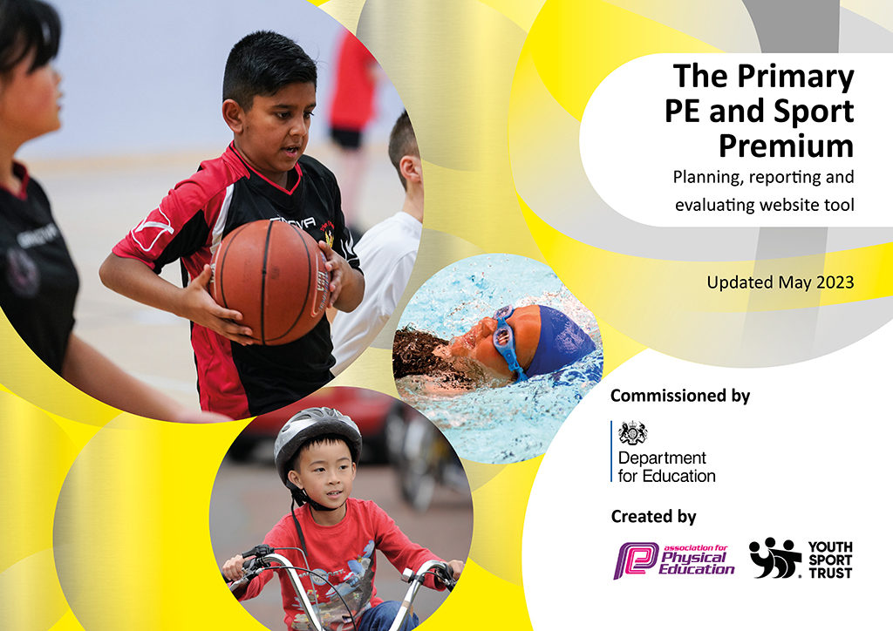
Updated July 26
Thomas Wolsey Ormiston Academy Primary Sport and PE Premium 2024-2025
Published 27th July 2025
Details with regard to funding

Total amount carried over from 2024/25 | £0
Total amount allocated for 2024/25 | £16,400
How much (if any) do you intend to carry over from this total fund into 2026/27 | £0
Total amount allocated for 2026/2027 | £
Total amount of funding for 2025/2026 spent and reported on by 31st July 2026 | £16,400
Swimming Data
Report on Swimming Data below.

Meeting national curriculum requirements for swimming and water safety.
- All pupils at TWOA are working significantly below age-related expectations in all curriculum areas. All pupils therefore follow personalised programmes of study and work towards personalized swimming goals.
- Our intended offer is for 100% of our primary pupils to have access to a weekly swim session or, for our youngest pupils, a weekly swim session on a half-termly rota’d basis.
- Pupils access instruction on water safety in ways relevant to their level of understanding in PSHE and swimming lessons.
- Percentage of your current Year 6 cohort swim competently, confidently and proficiently over a distance of at least 25 metres? | n/a
- Percentage of your current Year 6 cohort use a range of strokes effectively [for example, front crawl, backstroke and breaststroke]? | n/a
- Percentage of your current Year 6 cohort perform safe self-rescue in different water-based situations? | n/a

- Schools can choose to use the Primary PE and sport premium to provide additional provision for swimming but this must be for activity over and above the national curriculum requirements. We have used it in this way. | Not in 25-26

Action Plan and Budget Tracking
Intended annual spend against the 5 key indicators, success criteria and evidence of impact for pupils today and for the future.

Academic Year: 2025/26 | Total fund allocated: £16, 400 | Date Updated: July 25-26
Key indicator 1: The engagement of all pupils in regular physical activity – Chief Medical Officers guidelines recommend that primary school pupils undertake at least 30 minutes of physical activity a day in school |  |  |  | Percentage of total allocation:
Intent | Implementation |  | Impact of 25-26 objs | Sustainability and suggested next steps
The majority of pupils to gain the skills identified in their personalized PD goals. These will vary according to pupil.  Examples are:  - Increase the distance I walk in my walker  - Bench sit for an activity for up to 10 minutes  - Participate in a range of bilateral activities  - Move my head to the midline in order to participate in a range of activities  - Use right hand to explore motivating objects  All pupils to develop knowledge, skills and understanding in specific areas of PE delivered in time-tabled PD sessions or in enrichment sessions. Examples of sports delivered during 25-26:  - Yoga (copying and repeating movements, sequencing movements, awareness of body and how it moves through space, creative expression)  - Tennis and cricket (hand-eye coordination, working as a team, learning & following rules of play)  - Active Week (personal challenge & goal-setting, experiencing new sports) | - Personalised daily time-tabled postural management programmes integrated into school day, e.g. using walker or self-propelling from the bus to classroom, to PC, in stander whilst reading  - Pastoral teams coordinate with PT and OT to develop programmes  - Outdoor & indoor physical play opportunities, e.g. soft play, accessible playground equipment, disability bikes etc.  - Weekly or ½ termly swimming sessions in school pool  - Weekly PD session with focused skill development  - Movement-based lunchtime clubs – parachute games, Music and Movement |  | - 63% of pupils achieved personalized P & S learning goals in Autumn/Winter semester 2025-26  - 73% of pupils achieved personalized P & S learning goals in the Spring/Summer semester 2025-2026  - All pupils (except those for whom it would be detrimental to their health) accessed swimming regularly  - Increased independent movement & confidence around the school  - Participation in new sports & working with other PD professional organizations delivered in Active Week: Dance East, Therapy Gyms, Orwell Panthers (athletics) | - 23-24 - New M & H instructor to complete M & H risk assessments for all pupils  - Update 24-25 – All complete – delivered  - Update 25-26 – Reviews in place – sustained  - 23-24 - Newly qualified Rebound Therapists and Swimming Instructors to start delivering sessions  - Update 24-25 5 out of 6 Rebound Therapists have delivered RT to pupils in 4 classes over the course of the year, 2 further Rebound Therapy Instructors have been trained to replace staff that have left. The school now has a team of 5 Rebound Therapists. 2 new swimming instructors are now teaching ½ day a week and are ready to teach 1 full day a week in Sept  - Update 25-26 – 2 new swimming instructors are now teaching 1 day a week and have also covered absence of Lead Swimming Instructor, demonstrating competence & confidence in role.  - 23-24 = 3 new wheelchair bikes: 2 wheelchair loading bikes & 1 tandem have been purchased. Old stock has been serviced. Several classes have had regular biking sessions during the summer term.  - Update 24-25 – Bikes have been well-used in warmer months. Delivered.  - Update 25-26 – Bikes have had a full service over the summer. An additional cycle path has been added to the field giving a longer path for pupils to cycle on. Bikes have continued to be well-used over the warmer months - sustained
Key indicator 2: The profile of PESSPA being raised across the school as a tool for whole school improvement |  |  |  | Percentage of total allocation:
Intent | Implementation |  | Impact of 25-26 objs | Sustainability and suggested next steps
- Access to outdoor learning spaces continues to be further embedded through:  - Extending the D of E offer from Bronze to Silver Award and extending the expedition element to include outdoor camping and outdoor pursuits – whilst this is for Secondary it raises the profile and is aspirational for Primary pupils  - Ongoing maintenance and promotion of disability bikes  - Increased offer of PD focused lunchtime clubs  - Promote inclusive PD and raise awareness of local organizations through a week-long Active Week  - Numeracy learning is embedded through outdoor play | - Expanded D of E program  - M & H instructor to continue to support classes access disability bikes  - Pupil-led football club  - Active Week to run in Summer Term  - Numeracy cue cards giving ideas of how Numeracy and outdoor play can be fully integrated |  | - 4 pupils achieved Silver D of E Award for the first time in the academy – this has proved to be motivational for Primary aged pupils  - Expedition element involved outdoor camping and outdoor activities – again proving motivational for younger pupils  - Up to 10 pupils of mixed age and stage enjoyed the opportunity to mixed outside of their class groups  - All statutory-aged pupils across school accessed a new fully inclusive PD opportunity with an outside provider. All pupils accessed a range of engaging, PD-focused activities which as part of the week | - 23-24 - Core expectations of access to outdoor areas every day.  - Update 24-25 – although further progress still needed, Primary teachers problem-solving challenges of access, e.g. split groups & using a hoist on a board to access grass. Some areas, especially EYFS very well used exceptionally well-used.  - Update 25-26 – all classes are now making fuller use of gated outdoor learning areas. Primary classes all accessed woodland or forest areas in the summer term linked with curriculum topic  - 24-25 – Whole-school focus on Numeracy learning through outdoor play  - Update 25-26 Further embedding still needed. Strong in some classes.  - 24-25 - Increase use of allotment for a range of purposes, e.g. regulation & sensory breaks  - Update 25-26 – Delivered. Allotment has been well-managed and linked to purposeful learning primarily through the D of E. Upper school classes have taken responsibility for maintaining 1 bed each and having a dedicated staff member has meant that this has been able to support learning effectively  - 25-26 – First Active Week took place engaging whole school community – delivered. Template is in place for regular feature.  - 25-26 - School Games Mark Silver Award achieved in June in recognition that the school provides ‘high-quality opportunities for pupils to be physically active, participate in competition and develop a lifelong engagement with sport and physical activity.’

Key indicator 3: Increased confidence, knowledge and skills of all staff in teaching PE and sport |  |  | Percentage of total allocation:
Intent | Implementation | Impact of 25-26 objs | Sustainability and suggested next steps
- Rebound Therapy is extended to a wider number of children  - 2 new swimming instructors build their confidence and skills in delivering swimming on their dedicated day and covering swimming on days where needed  - PD Lead builds confidence and knowledge around specialist disability sport and specialist PD curriculums  - Lead Swimming Instructor revises swimming offer and brings this in line with TWOA assessment toolkit and builds leadership skills by supporting new swimming instructors in their delivery  - New swimming instructors learn how to manage and coordinate swimming, navigating the needs of a range of stakeholders  - Rebound Therapist adopt TWOA assessment toolkit – adapting this to TWOA assessment toolkit | - Rebound Therapists are given time to plan & write up sessions.  - Newly trained Rebound therapists are upskilled through modelling or pairing with more experienced staff  - New swimming instructors deliver a wider range of sessions or their own sessions independently  - PD Lead is allocated additional time for preparation of Active Week and the planning and organizing of specialist sporting opportunities | - Coherent and consistent approach to the assessment of Rebound Therapy and Swimming bringing clarity to delivery of both  - New swimming instructors now leading swimming with confidence  - PD Lead steering the PD offer across school and initiating local opportunities for inter-school competitions and new PD-focused enrichment activities, e.g. tennis, full organization of sailing without needing support, independent organization of Active Week | - 23-24 - New PD lead to continue building his own knowledge, skills and connections in disability sports and sourcing opportunities locally, e.g. therapy gym, cricket, sailing, boccia.  - Update 24-25 – PD lead has now led sailing & gained further knowledge of disability cricket – delivered  - Update 25-26 – PD lead has facilitated pupil-led lunch-time football club, begun drafting a new coherent whole-school PD curriculum, organized a week long PD enrichment event ‘Active Week’, continued to create opportunities for inter-school competition & set up new PD opportunities locally including tennis and athletics. He now confidently coordinates existing provision and opportunities including Sailing and Schools Games events.  - 24-25 – Two new swimming instructors starting to build confidence & skills in leading swimming sessions  - Update 25-26 – 2 new swimming instructors are now teaching 1 day a week and have also covered absence of Lead Swimming Instructor, demonstrating competence & confidence in role  - 24-25 – Rebound Therapy opportunities to be extended so at least 50% of classes have an opportunity to access it  - Update 25-26 see above – target of 50% has not been reached due to staff retention but assessment systems have been brought in line with wider school systems making it easier to track progression and link this to EHCP goals  - 24-25 – Establish a fully inclusive sports week (including internal swimming gala) to replace sports day moving forward  - 25-26 - Active Week took place in Summer 2. This was a very successful event. A template has been established for this to be a fixed event each year.  - 23-24 - Establish some Rebound Therapy sessions across school  - Update 24-25 - Rebound Therapy has been delivered to 4 Primary classes  - Update 25-26 – Rebound has been consistently delivered in 2 classes. 2 further instructors have been recruited to support fuller roll out across school.  - 23-24 = Ensure there are schemes of work and progression in place for swimming and Rebound Therapy  - Update 24-25 Winstrada Progression pathway is used for Rebound Therapy & further lateral progression pathways are being developed. Swimming SoW are in place  - Update 25-26 -
Key indicator 4: Broader experience of a range of sports and activities offered to all pupils |  |  | Percentage of total allocation:
Intent | Implementation | Impact of 25-26 objs | Sustainability and suggested next steps
- Build links with Henley Sports Club and introduce disability tennis to pupils at school  - Provide all statutory school aged children with opportunity to experience a new sport delivered by an external sports provider  - Established sporting activities are extended to new students: Rebound, cricket, Presidents Day sporting activities, e.g. space hopper football | - Blocks of tennis sessions delivered to identified children  - Opportunities for all children to engage in new activities with local providers through Active Week  - Selected class to attend Presidents Day | - Blocks of tennis sessions delivered to identified children (although Secondary pupils this year this has established a precedent for Primary aged pupils, building links with sports facilities in the local community.  - All children of statutory school age accessed an external sports coach during Active Week – Dance East, Orwell Panthers and Fitness for All Therapy Gyms provided new, age and stage appropriate workshops for all children  - 8 pupils attending Presidents Day tried new sports, (such as space hopper football) and found how much fun sport can be. | - 24-25 – Extend and embed resources purchased following sessions with Therapy Gym, e.g. Cosmo and pedal exercisers  - Update 25-26 – Cosmo has been consistently used in 4 classes

Key indicator 5: Increased participation in competitive sport |  |  | Percentage of total allocation:
Intent | Implementation | Impact of 25-26 objs
- TWOA pupils to participate in competitive sporting events organized through Inclusive Schools Games, e.g. Panathlon  - Local ‘friendlies’ to be organized between TWOA and other special schools in disability sports | - PD lead to organize attendance at Inclusive Games competitive events  - PD lead to continue to investigate opportunities locally & invite local specials to school if none exist | - 1 boccia ‘friendly’ took place between Riverwalk and TWOA  - A selection of pupils across school participated in sporting events with a competitive element including Panathlon and bowling | - 25-26 - 1 boccia ‘friendly’ took place between Riverwalk and TWOA  - A selection of pupils across school participated in sporting events with a competitive element including Panathlon and bowling

Signed off by
Co-Principal: | Emily Webster
Date: | 31st July 2026
Subject Leader: | Aaron Spalding
Date: | 31st July 2026
Governor: | Lynne Goodwyn
Date: | 31st July 2026

